FACILITY-LEVEL TECHNO-ECONOMIC POTENTIAL OF ELECTRIFIED INDUSTRIAL PROCESS HEAT IN EUROPEAN MANUFACTURING
Anna Yuen^{1, *}, Emilia Chojikiewicz¹, Amol Phadke²
¹Energy and Resources Group, University of California, Berkeley, United States
¹Energy and Resources Group, University of California, Berkeley, United States
²Goldman School of Public Policy, University of California, Berkeley, United States
*Corresponding author. Email: anna_yuen@berkeley.edu

Keywords: INDUSTRIAL DECARBONISATION, HEAT PUMPS, HEAT BATTERIES, OFF-GRID SOLAR PV, TECHNO-ECONOMIC ANALYSIS

Abstract
Industrial process heat dominates manufacturing emissions in the EU. Roughly 75% of energy used for industrial process heat is powered by fossil fuels. Yet, there are readily available solutions that can continuously generate process heat. Industrial heat pumps and thermal energy storage solutions paired with on-site solar PV can be a solution to bring power to heat generation quickly and cost competitively with natural gas. Using a dataset of 2,192 facilities of different manufacturing sectors from Climate TRACE, each facility is modelled with co-located, off-grid solar PV with industrial heat pumps and batteries installed in 2030. Under this modelled configuration, 59% of fossil-fuelled process heat can be decarbonized using solar PV within a 5 km buffer zone around each facility site at an average levelised cost of heat of €55/MWh. After expanding the buffer zone to 15 km, the share of possible decarbonized heat rises to 84% of process heat at €62/MWh against an EU average gas-heat cost of €93/MWh. Each facility is optimized to provide the highest availability and highest savings under its country's gas costs. These results show that Southern Europe can cost-competitively decarbonize over 95% of its heat demand. Central Europe (Rhine-Meuse Region), where most of the large, heat intensive sources are located, can decarbonize over 70% of its heat demand using on-site solar plus storage.

Introduction
- Problem: Fossil fuel makes up ~75% of industrial process heat in EU in 2019.
- Technology: heat pumps and electrified thermal energy storage
  - Heat pumps are commercially ready, and electrified thermal energy storage (ETES) is rapid advancing
  - Explain how heat pumps (COP) and ETES work
- Current barriers:
  - High electricity prices: Average industrial electricity prices are €162/MWh, €77/MWh more than average glass prices with carbon tax.
    - Total Industrial Bill = Commodity Energy + Network/Capacity Fees + Taxes/Levies + Grid Service Fees
    - Commodity energy: what you get from energy market
    - Network/Capacity Fees: what you pay to the TSOs (state owned grid infra). Most impacted by high congestion windows.
    - Taxes/Levies: carbon tax
    - Grid Service Fees: machinery to manage reactive energy
    - Mostly volumetric costs dominate bill
    - High exposure to wholesale prices
    - Non-firm supply is commonly enforced.
    - Recently Germany had a 5-cent cap per kWh to subsidize their industrial energy use
  - Long interconnection queues: variable. Ranges from 3 years in Southern Europe and 5-10 years in Netherlands and Germany (big industrial manufacturing hubs)
  - Gas dependence and energy security: Russia-Ukraine war, Strait of Hormuz. International conflicts that increase gas prices by 125-150%.
- Context for off-grid energy system
  - Land permits: can take 12-24 months to get approved. Member states must map suitable land by 21 May 2025. They also would need EIA Directive
  - France and Italy do not allow solar farms on cropland or limit the amount of PV.
  - Process (2-5 years):
    - securing the land (lease 25-30 years)
    - rezone or plan for rezone with approval for public and municipal approval
    - Environmental review
    - Building permit and connection route. Solar farms need private line/heat pipe to plant which would require easements, road and river crossings.
- Literature review:
  - Off grid/collocated renewable heat studies (Dominguez, et al. (IECC))
  - Saad has worked on facility level heat demand in the US. McMillan has done facility-level technical potential of alternative thermal sources to meet industrial heat demand in the US using GHGRP data.
  - Markussen did a TEA of technologies for decarbonizing low & medium temperature industrial heat but not for solar + TES systems.
  - Table to compare scope: facility level, spatial resolution, technologies, off-grid, hourly dispatch, country-specific costs and benchmark
    - Our study contains high fidelity modeling
  - Add something about hierarchical optimization to fill in the blanks
- Gap and contribution
  - First facility level assessment of off-grid solar + heat pump + ETES for EU process heat
  - Co-optimized for site-specific hourly solar, land availability, country specific costs and WACC
  - Comparison of max savings and max heat
  - Spatial analysis of regions

Results
- Max saving and Max heat comparisons: Majority of heat can be decarbonized at below LCOH
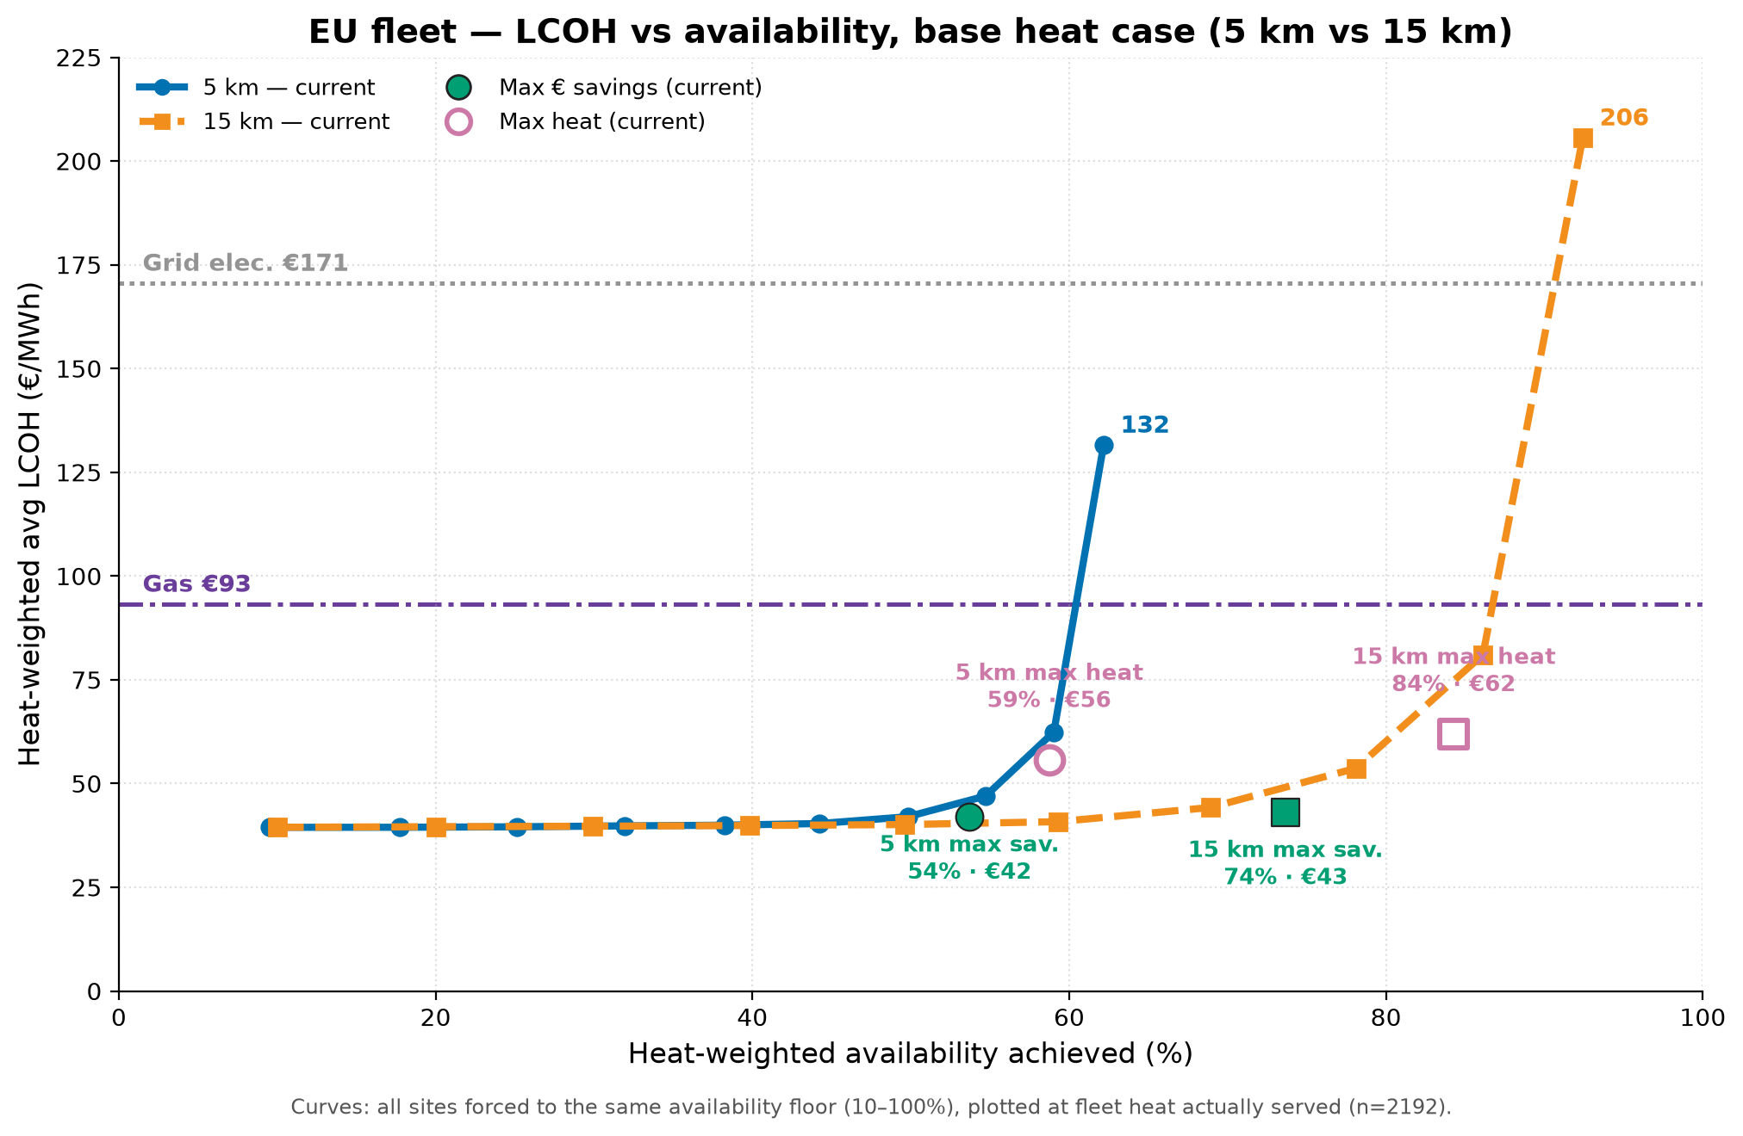
- Regional analysis
  - Heavy industrial customers (Germany, Netherlands) can have around 2/3rd of their heat demand supplied through this solution
  - Southern Europe is already able to meet their heat demand.
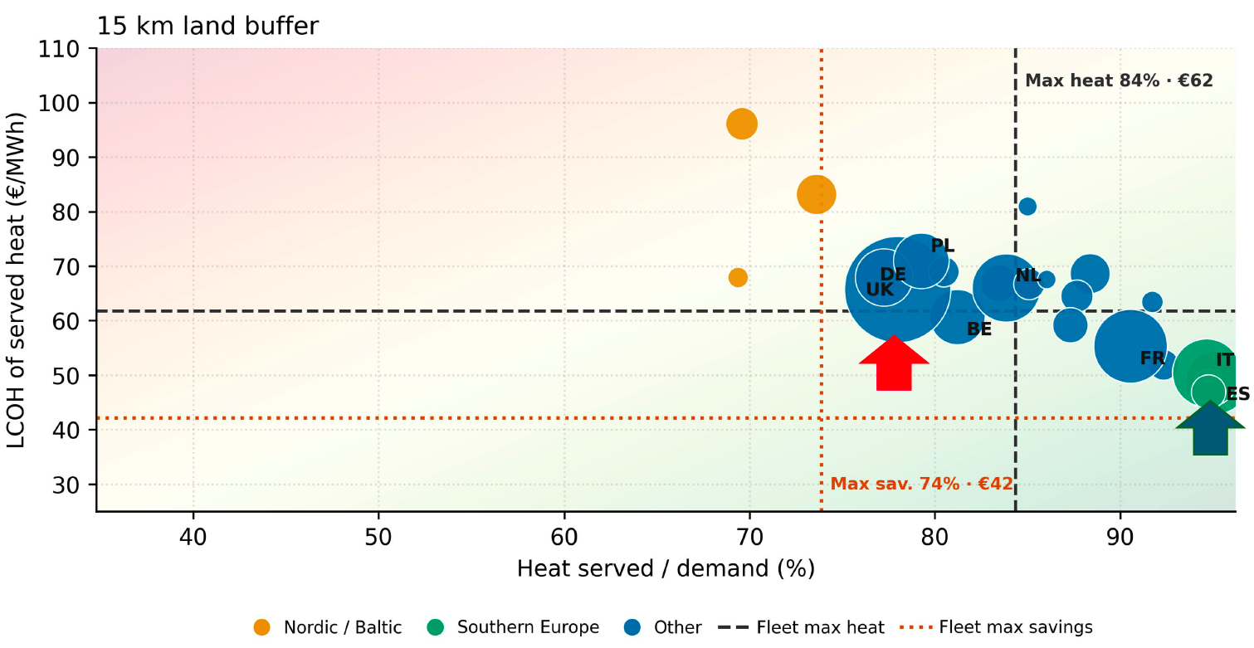
- Analysis by industry: food & beverage, iron & steel, chemical, etc. with temperature bands
- Solar resource vs land constraint

Sensitivity and uncertainty analysis
- Could also just note it instead of putting it in the main paper. In order of importance:
  - Heat demand: increase and decrease the heat demand
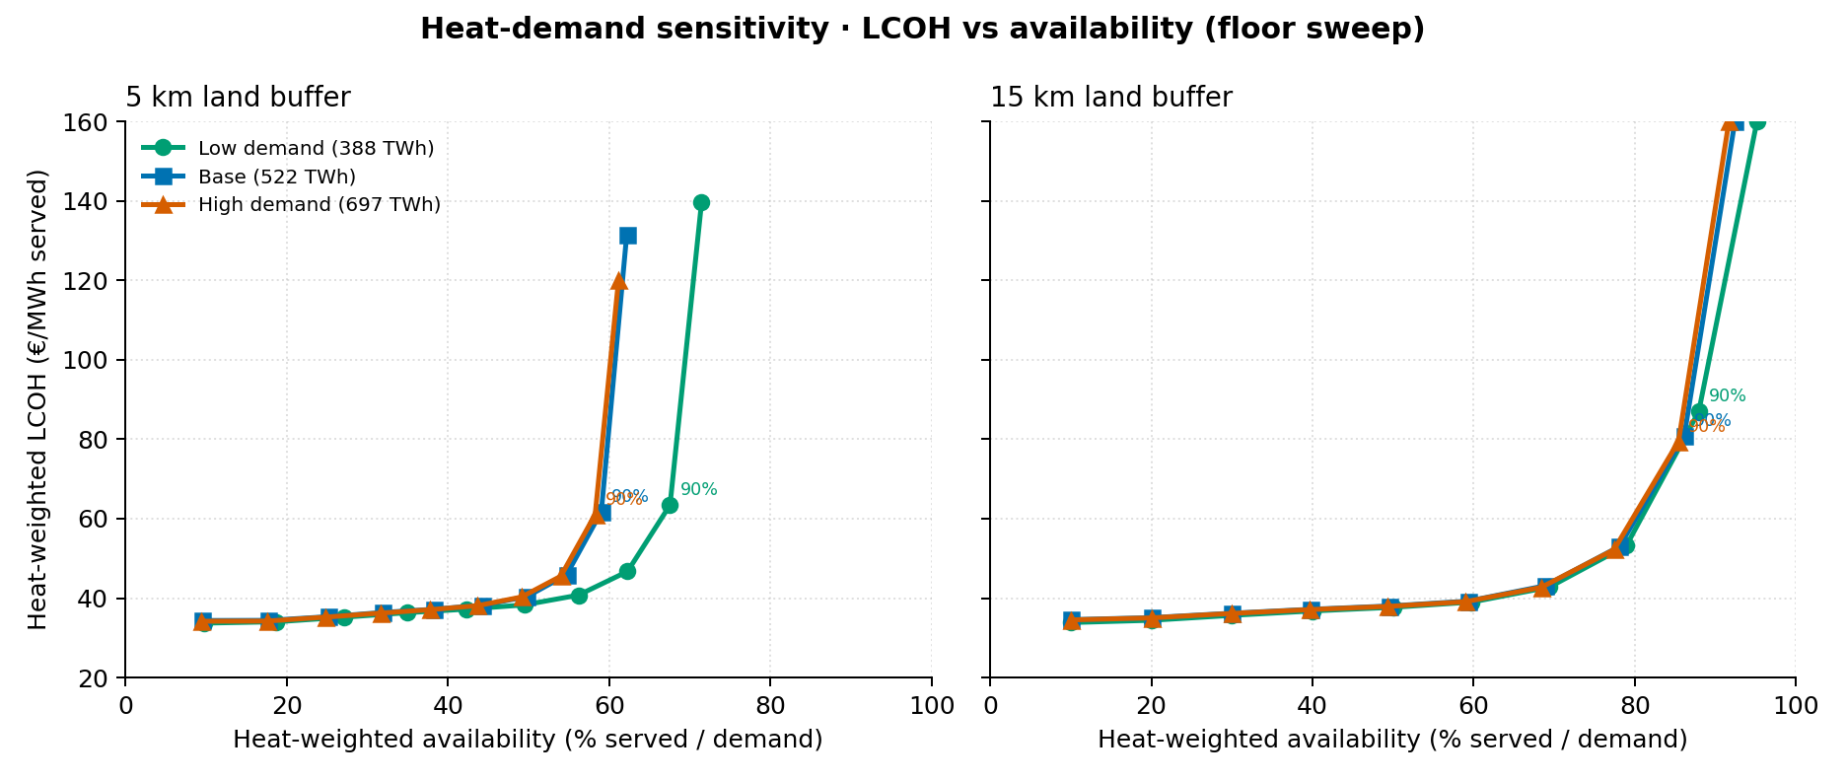

The heat demand sensitivity is mostly showing how much heat can be served before land runs out, not whether prices change. The base is mostly aligned with high demand which means that heat demand does not influence LCOH or heat demand served past the baseline mark.

  - Capex of prices – How confident am I about the numbers for heat battery?
  - Land availability – Already kind of did that with the 5/15 km land buffer but can try with average land prices?
  - Weather variability – LCOH might not be impacted more
  - Carbon tax/ Gas prices: what is the difference on low gas prices compared to average?
    - Probably not as interesting to do since the result is already much lower than gas prices.

Discussion
- Cost of grid electricity and potential for that to work with off grid to manage load.
- Flat load assumption
- Heat demand data
- Land acquisition process: Examine the minimal cost of land to be under gas prices.
- Analysis of land lease prices:
  - How much land per MW: 100 ha/km² ÷ 50 MW/km² = 2 ha/MW
  - For each site and lease price, I take the availability sweep points and each site's gas-capped point and add the lease cost for the land it uses. Then I keep the point that serves the most heat while staying at or below that country's gas cost. So, at a higher lease, a site can step down to a lower availability instead of dropping out entirely.
    - LCOH_served + p × ha / served_MWh ≤ gas cost (€/MWh)
Most of those sites have a large margin. Adding €3,000–5,000/ha-yr only costs a few €/MWh, so they stay below gas.
Only sites close to the gas price drop out or fall back to a lower-availability point. 15 km goes from 85.0% to 82.5% at €3,000 and 80.9% at €5,000. 5 km goes from 59.6% to 58.5% and 57.8%.

Its gas heat cost is €81.4/MWh
1566430 in the 15 km scenario
Served (MWh/yr) | Land (ha) | LCOH, no land (€/MWh) | Total at €3,000 | Total at €5,000
817,303 | 1,293 | 40.9 | 45.7 | 48.9
934,061 | 1,690 | 45.2 | 50.6 | 54.2
1,050,818 | 2,804 | 62.5 | 70.5 | 75.9
1,076,036 | 3,364 | 71.1 | 80.5 | 86.7

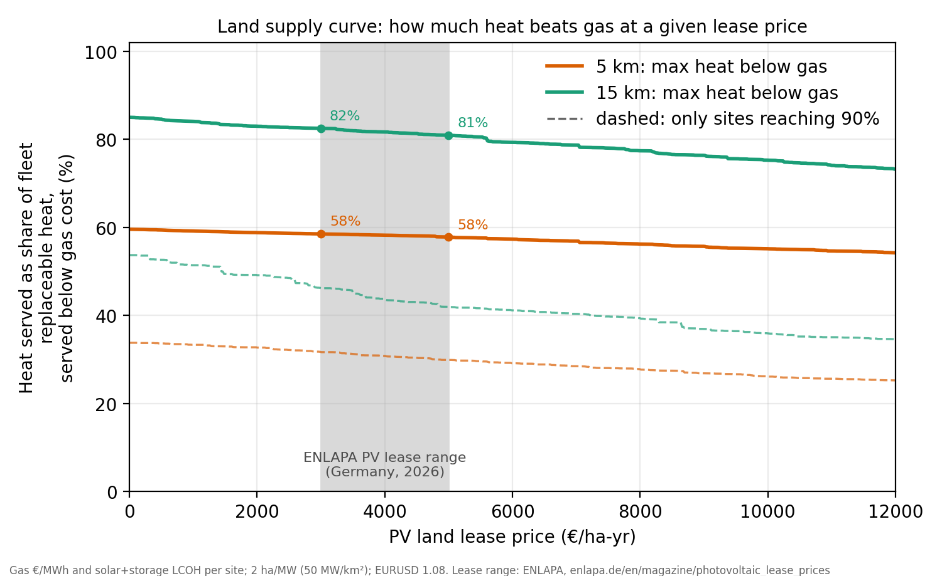

Data
- Heat pump and IHB costs
Band | Rissman (2022; IHB 2023) | DEA (2026), equipment only | Model now (2030 USD)
<100 °C CAPEX | $700/kW_th (2021 USD, 80–100 °C unit, equipment only) | €380/kW_th (2025 €), which is 40% of €950 installed (hot water to 60 °C, 40 K lift) | $918.30/kW_th
<100 °C O&M | $2/MWh_th | €2.13/kW_th-yr fixed + €3.07/MWh_th variable | $15.74/kW_th-yr fixed O&M (FOM), no variable O&M (VOM)
100–200 °C CAPEX | $870/kW_th (2021 USD, 100–180 °C unit, equipment only) | €620/kW_th, which is 40% of €1,550 installed (hot water to 150 °C); €700/kW_th for steam (40% of €1,750) | $1,141.31/kW_th
100–200 °C O&M | $3/MWh_th | €2.49/kW_th-yr fixed + €3.60/MWh_th variable | $23.61/kW_th-yr FOM, no VOM
>200 °C heat battery (IHB) | $100/kW input + $300/kW delivery + $5/kWh storage (2023 USD) | Not provided | $116.66/kW in, $349.99/kW out, $5.83/kWh

DEA's datasheet splits investment into 40% equipment and 60% installation. I multiplied each installed (nominal) figure by 0.4. O&M isn't split between equipment and installation, so it's shown as published. DEA values are 2025 euros with no currency or CPI conversion. At an assumed 1.1 USD/EUR, equipment-only comes to about $418 and $682/kW_th, or $770 for steam.
Rissman's $700 and $870 are in 2021 USD, which is about $832 and $1,034 in 2025 USD. DEA equipment-only therefore comes out below Rissman, even before accounting for Rissman's earlier year.

COP bands
HP delivers heat at the band's temperature, and the medium is not modeled. Steam would raise cost and lower COP and treat that as a limitation of the model. Optionally, could put a +0.20 M€/MW adder and the −0.15 COP penalty to the 100–200 °C band when the load is steam.
Heat pumps are modeled by delivery-temperature band with a fixed COP and capacity cost. The delivery medium (hot water or steam) and temperature lift are not modeled. That would require steam at each band and sector to be determined.

Band | Rissman(2022) | DEA(2026) | Model now
<100 °C | 3.7 (80–100 °C unit) | 5.28 (40 K lift, to 60 °C); 4.52 (50 K, to 70 °C); 3.95 (60 K, to 80 °C) | 3.7
100–200 °C | 2.2 (100–180 °C unit) | 2.70 annual average (65 K lift); 2.40 (80 K); 2.05 (100 K); steam subtracts 0.15 | 2.2
>200°C | 1 | - Not provided | 1

Methods
- 2149 facilities (522 TWh/yr replaceable heat)
- Replaceable heat = production * SEC (useful process heat) * fossil share. Split into flat hourly loads to simplify optimization model. Feedstock energy is excluded.
- < 200°C uses solar => li-ion => heat pump; >=200°C is solar => IHB
- PVGIS 2023 weather data with 1kWp DC nameplate, no loss, fixed tilt, no tracking.
- Inverters derate is applied (0.967).
- Land cover includes bare + cropland with protected land mask
- Solar nameplate energy is caped at 50 MWdc/km^2
- HP&IHB capex is inflated to 2030 USD and solar + li-ion uses BNEF 2030.
- LCOH served is the annual capacity/served heat.
- Optimization looks at max served first. How much it would cost to maximize heat served.
- Then calculate maximizing saving using: Surplus maximizing point = max saving = heat served *(93-LCOH).
- Optimization is only run for each decile for each facility.

Subsector | n | min TJ/yr | median TJ/yr | mean TJ/yr | max TJ/yr
petrochemical-steam-cracking | 36 | 2,759 | 14,811 | 17,435 | 49,368
iron-and-steel | 112 | 106 | 1,798 | 5,075 | 45,643
chemicals | 49 | 428 | 3,381 | 4,575 | 22,808
pulp-and-paper | 79 | 54 | 1,496 | 1,954 | 7,035
cement | 198 | 82 | 1,626 | 1,896 | 6,437
aluminum | 28 | 9 | 350 | 1,446 | 11,842
glass | 148 | 151 | 796 | 1,140 | 5,661
lime | 62 | 212 | 377 | 970 | 6,985
food-beverage-tobacco | 868 | 10 | 227 | 458 | 7,422
textiles-leather-apparel | 612 | 17 | 102 | 109 | 599

Optimization
Two phases solve:
- First phase sets the availability floor: Attempt to meet that availability floor.
- If that is not possible then the second phase minimizes the unserved demand and runs the optimization with that maximizing availability given the land available and solar radiation.
$$\min{ }Z=\frac{1}{E_{load}}\left[c_{PV}P_{PV}+c_{Li,E}E_{Li}+c_{Li,P}P_{Li}^{dis}+c_{IHB,in}P_{IHB}^{ch}+c_{IHB,out}P_{IHB}^{dis}+c_{IHB,E}E_{IHB}+\sum_{b∈B^{HP}}{c_{b}^{HP}}P_{b}^{HP}\right]; Z = LCOH$$
$$E_{load}=\sum_{b}{L_{b}}\sum_{k}{w_{k}}H$$

LCOH by components

$$Z=Z_{solar}+Z_{Li\text{-}ion}+Z_{IHB}+Z_{HP}+Z_{unserved}$$
$$Z_{solar}=\frac{c_{PV}P_{PV}}{E_{load}}$$
$$Z_{Li\text{-}ion}=\frac{c_{Li,E}E_{Li}+c_{Li,P}P_{Li}^{dis}}{E_{load}}$$
$$Z_{IHB}=\frac{c_{IHB,in}P_{IHB}^{ch}+c_{IHB,out}P_{IHB}^{dis}+c_{IHB,E}E_{IHB}}{E_{load}}$$
$$Z_{HP}=\frac{1}{E_{load}}\sum_{b∈HP}{c_{b}^{HP}}P_{b}^{HP}$$
Constraints:
- Shared solar limit:
$$\sum_{b∈B^{HP}}{x_{b,k,t}^{dir}}+p_{Li,k,t}^{ch}+p_{IHB,k,t}^{ch}≤P_{PV} g_{k,t}$$
- Storage State of Charge:
$$s_{Li,k,t}=s_{Li,k,t-1}+η_{Li} p_{Li,k,t}^{ch}-\frac{p_{Li,k,t}^{dis}}{η_{Li}}$$
$$s_{IHB,k,t}=s_{IHB,k,t-1}+η_{IHB} p_{IHB,k,t}^{ch}-\frac{p_{IHB,k,t}^{dis}}{η_{IHB}}$$
$$η_{Li}=\sqrt{RTE_{Li}}, η_{IHB}=\sqrt{RTE_{IHB}}$$
- Storage rate limit for each storage j ∈ {Li, IHB}:
$$s_{j,k,t}≤E_{j}, p_{j,k,t}^{ch}≤P_{j}^{ch}, p_{j,k,t}^{dis}≤P_{j}^{dis}$$
- Maximum storage duration:
$$E_{j}≤h_{max} P_{j}^{dis}$$
- Li-ion discharge to HP bands:
$$p_{Li,k,t}^{dis}=\sum_{b∈B^{HP}}{x_{b,k,t}^{batt}}$$
- HP heat balance and capacity:
$$COP_{b}\left(x_{b,k,t}^{dir}+x_{b,k,t}^{batt}\right)+u_{b,k,t}=L_{b} σ_{t}$$
$$COP_{b}\left(x_{b,k,t}^{dir}+x_{b,k,t}^{batt}\right)≤P_{b}^{HP}$$

- IHB discharge across temperature heat bands:
$$y_{b,k,t}+u_{b,k,t}=L_{b} σ_{t}$$

- Availability:
$$\sum_{k}{w_{k}}\sum_{t}{\sum_{b}{u_{b,k,t}}}≤\left(1-AF\right)E_{load}$$
- Bounds:
$$0≤P_{PV}≤P_{PV}^{max}$$
$$P_{j}^{ch}, P_{j}^{dis}, E_{j}, P_{b}^{HP}, x_{b,k,t}^{dir}, x_{b,k,t}^{batt}, y_{b,k,t}, p_{j,k,t}^{ch}, p_{j,k,t}^{dis}, s_{j,k,t}, u_{b,k,t}≥0$$

Phase 2 - Lexicographic/hierarchical optimization: Minimize the unmet amount, then minimize cost subject to that service level:
$$\min{ }U=\sum_{k}{w_{k}}\sum_{t}{\sum_{b}{u_{b,k,t}}}$$
Minimize unserved at every hour of every representative day and run the same optimization but with the optimal unserved amount ($U^{*}$).

$$\min{ }Z \text{s.t. constraints 1--8, 10, and} \sum_{k}{w_{k}}\sum_{t}{\sum_{b}{u_{b,k,t}}}≤U^{*}$$

Symbol | Meaning
$$B^{HP}, B^{IHB}$$ | Bands served by heat pump (COP > 1) or by IHB (COP ≤ 1)
$$g_{k,t}$$ | Solar capacity factor in hour t of representative day k (MW per MW installed)
$$L_{b}$$ | Flat heat load of band b ($MW_{th})$
$$σ_{t}$$ | Diurnal load shape, mean 1 (all 1 if flat)
$$y_{b,k,t}$$ | IHB heat delivered to band b
$$p_{j,k,t}^{ch}, p_{j,k,t}^{dis}, s_{j,k,t}$$ | Charge, discharge and state of charge of storage j
$$η_{j}$$ | One-way efficiency, the square root of round-trip efficiency
$$h_{max}$$ | Maximum storage duration, 16 h by default
$$AF$$ | Availability factor, which sets the share of heat that must be served
$$P_{PV}^{max}$$ | Optional solar cap from land limits (no cap if unset)
$$H$$ | Number of hours in representative days
$$x$$ | Electricity

